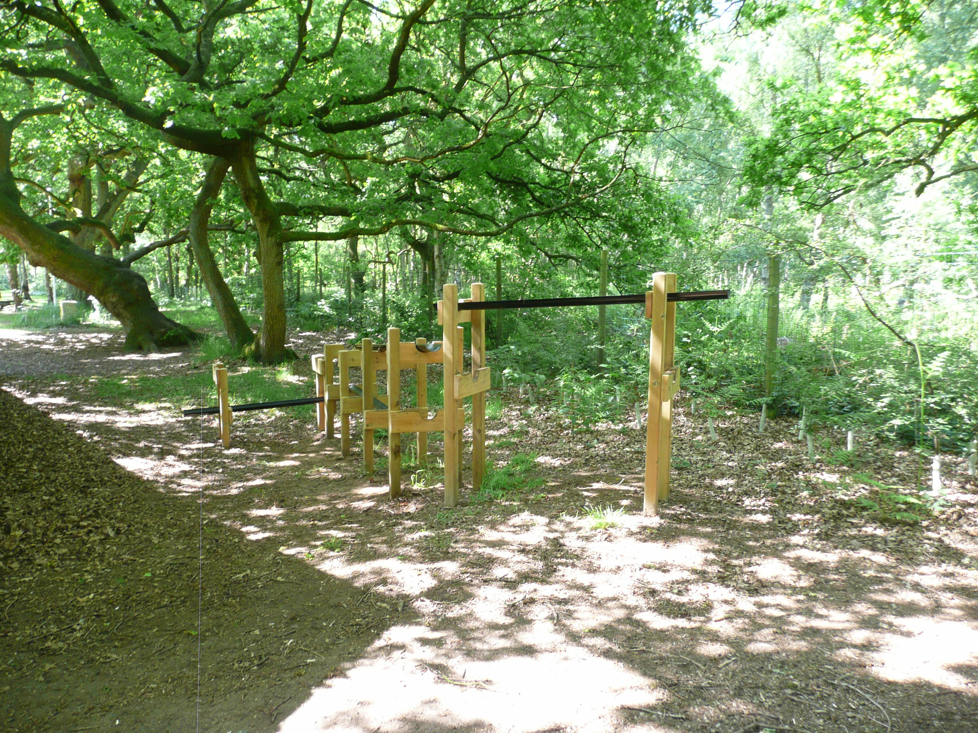
Water Chute
Working as a team use the guttering etc. in order to be able to pour water in at the top and collect it all at the bottom.
Leaders need to supervise this activity.

