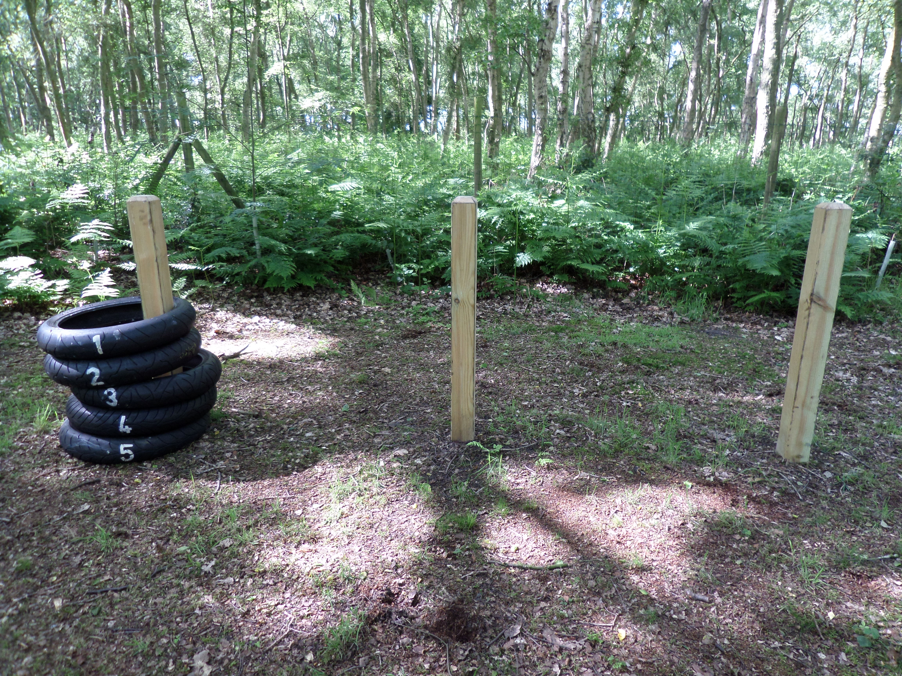
Tyre Challenge
Working as a team use the equipment provided to move the tyres in the same number order to the end pole.
You must only move one tyre at a time.
Adult supervision is needed for this activity.

