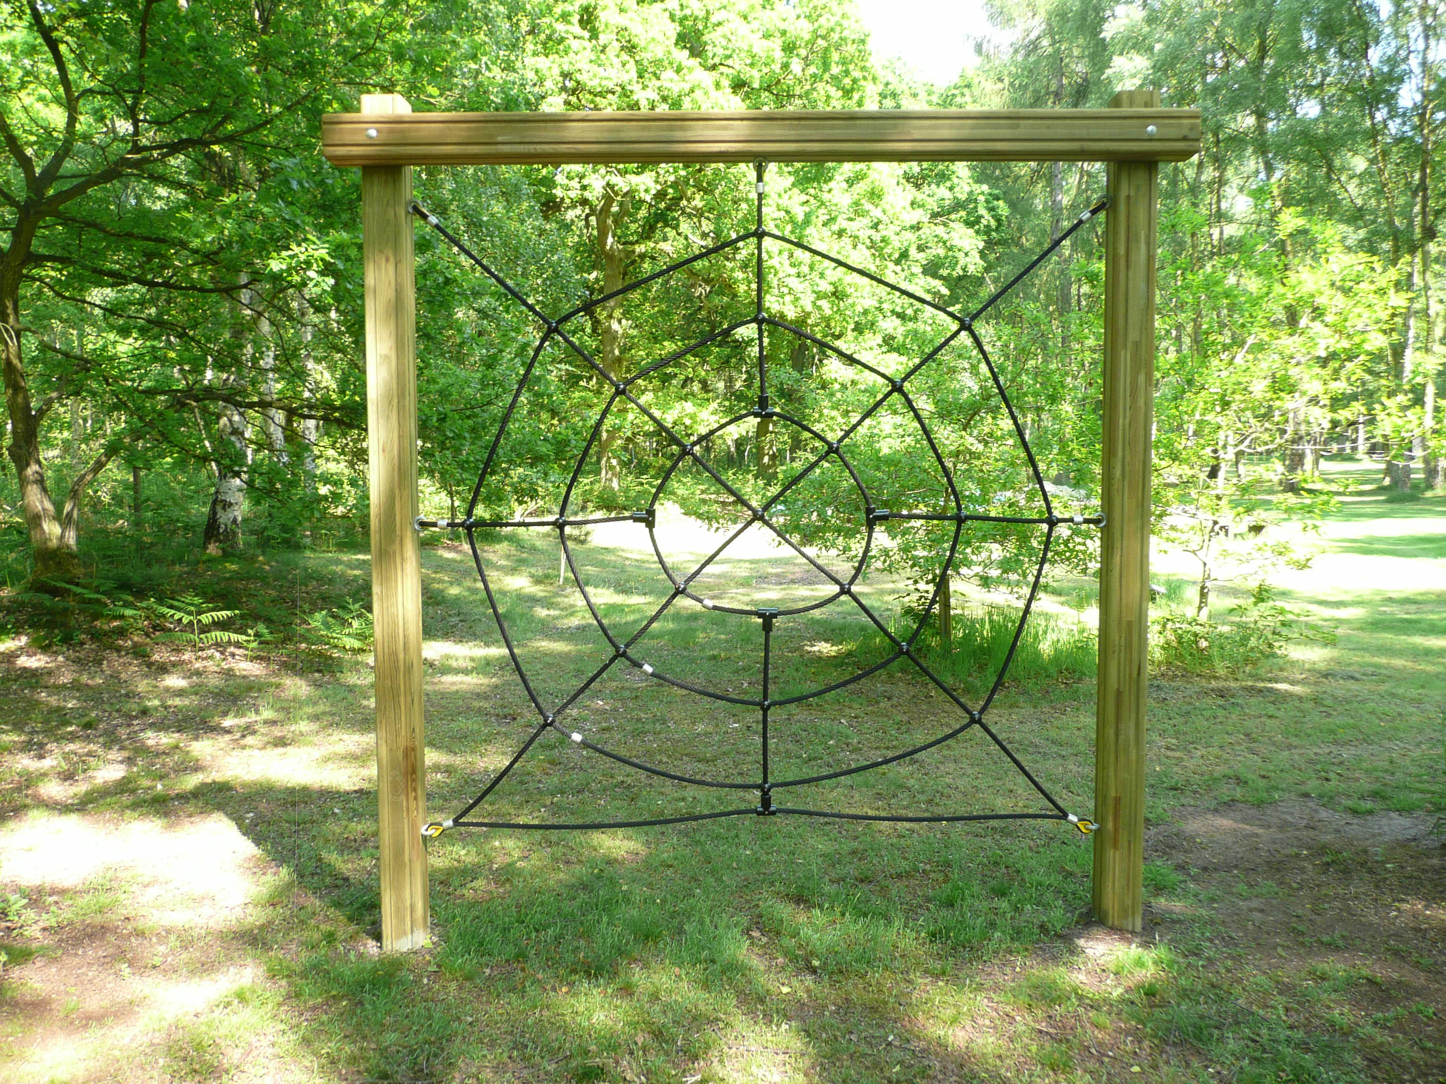
Spider’s Web
Work as a team to get all your members from one side of the web to the other.
Try not to touch the web as the giant spider will appear.
Each member should pass through a different section of the web.
Do not climb on the ropes or over the top. This is not a climbing frame.

Leaders need to supervise this activity.

