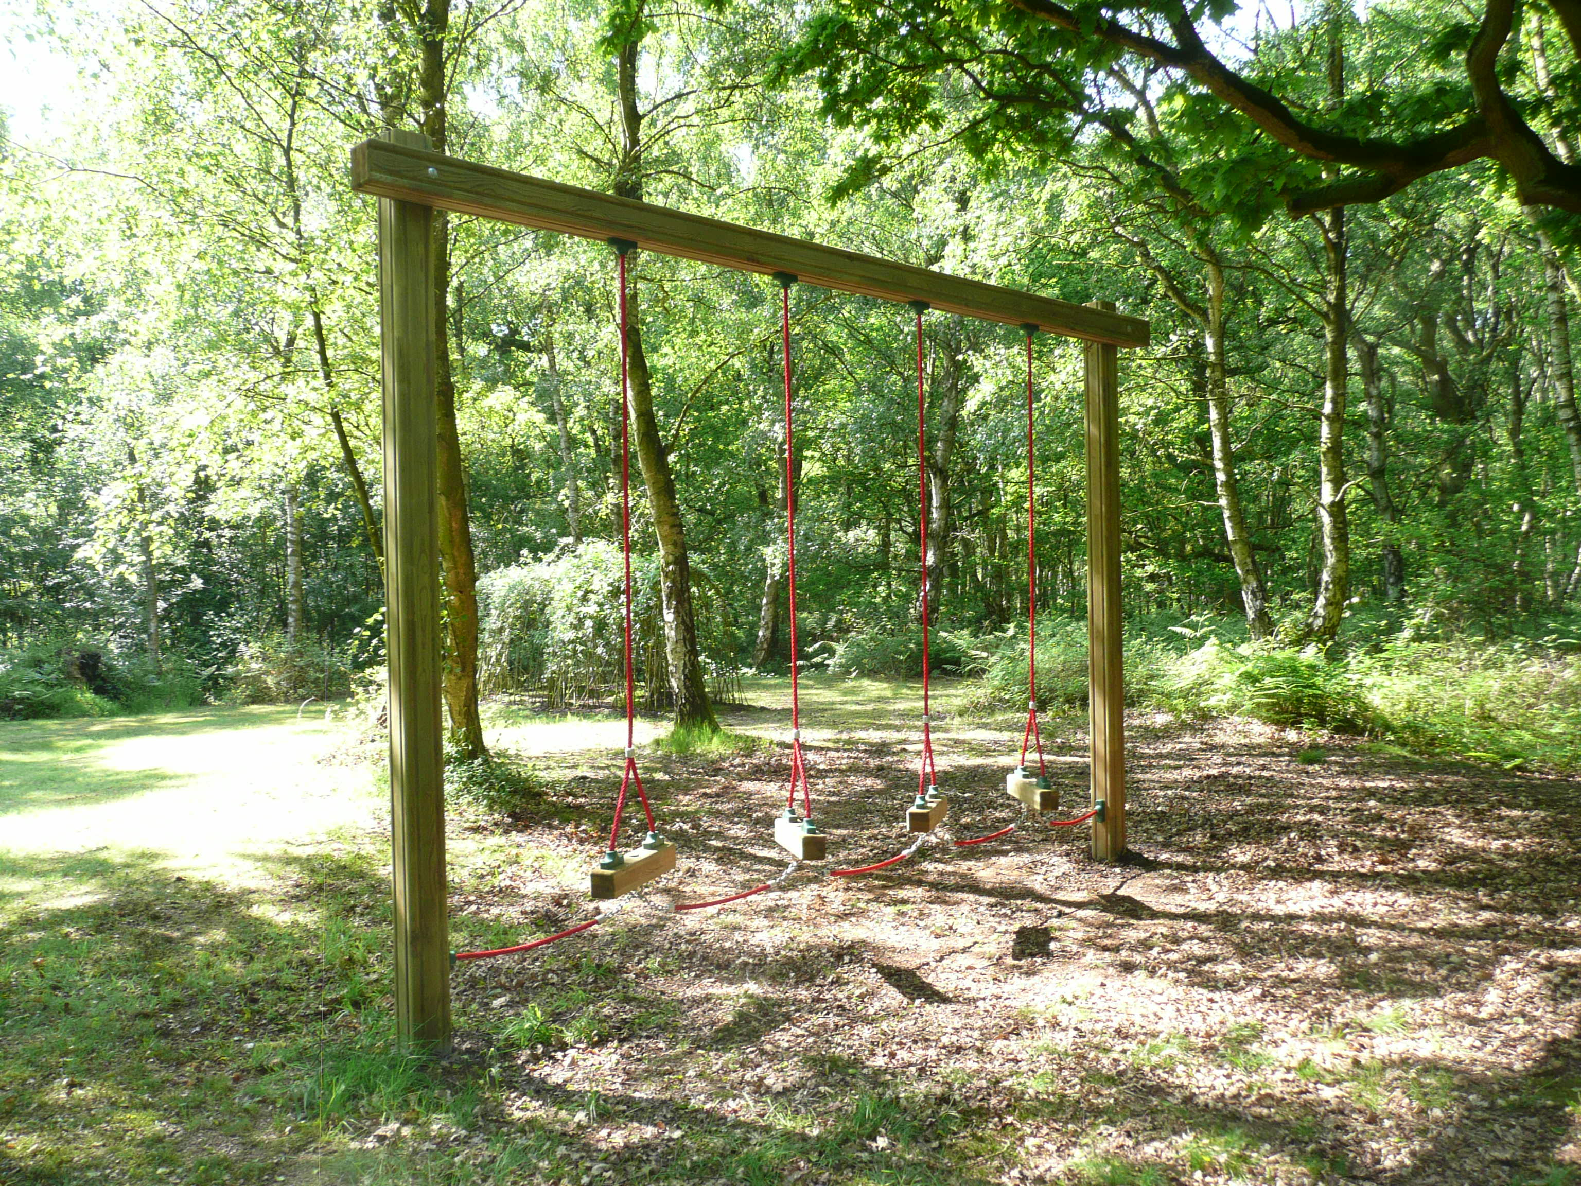
Log Traverse
As a team with one person working at a time get from one end of the equipment to the other without touching the ground.
If any member touches the ground they must start again from the beginning.
Leaders need to supervise this activity.

