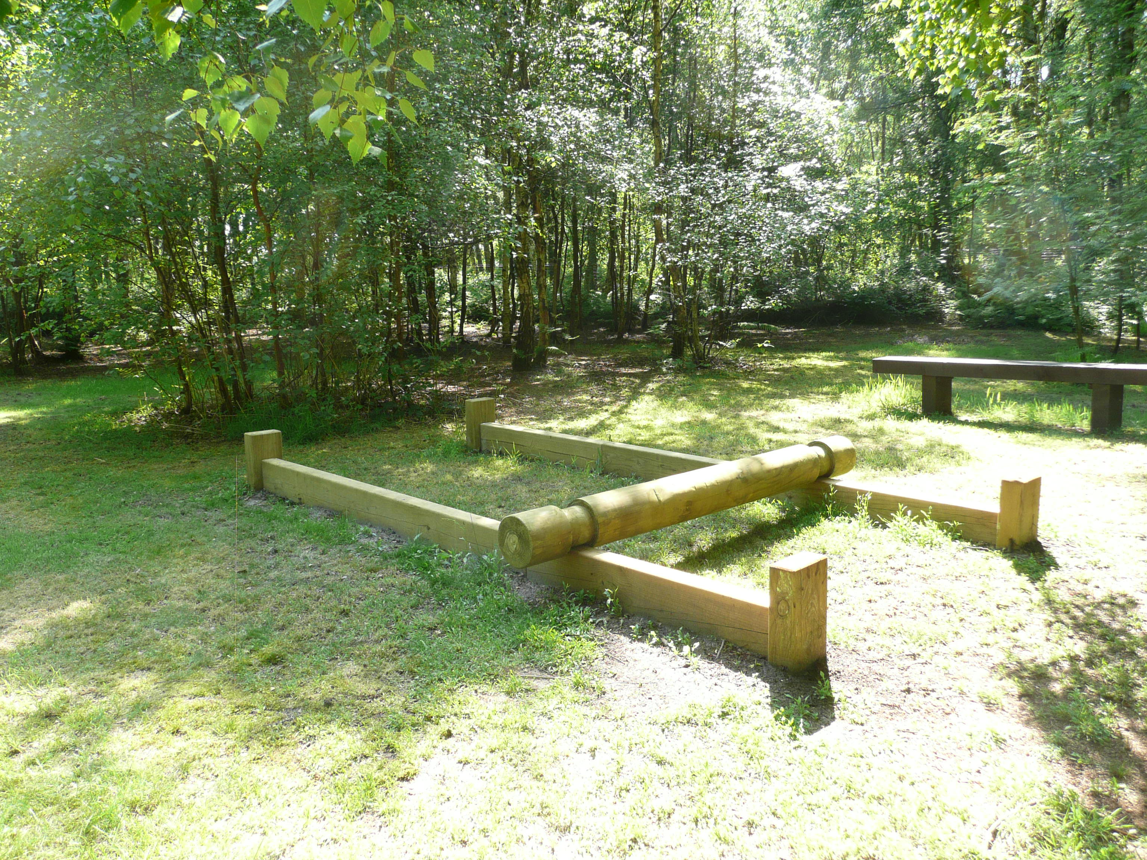
Log Roll
Only one person must be on the log at a time.
With the help of a member of your team to support you use your feet to roll the log from one end of the frame to the other.

Leaders need to supervise this activity.

