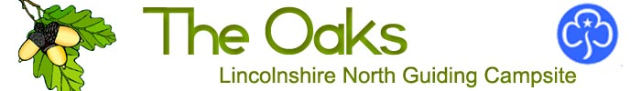 HEALTH AND SAFETY STATEMENT
The policy of The Oaks Campsite Management Committee is to provide safe and healthy working conditions for all users of the site.
CHILD PROTECTION MEASURES. It is the policy of Girlguiding to safeguard the welfare of all members and users of its premises by protecting them from physical, sexual and emotional harm. In order to meet these responsibilities, The Oaks Campsite Committee require that users of the campsite sign below, undertaking that all adults in their party have been deemed as suitable to work with young people from their own organisation, by holding a current DBS certificate, and that these adults understand that any contravention of Girlguiding’s Child Protection Policy could lead to Girlguiding initiating its reporting and referral procedures.
1. The Safety Officer for The Oaks Campsite is the Warden of the site. 2. Any person becoming aware of unsafe working practices, unsafe equipment or working conditions should report these to the Safety Officer. 3. Health and Safety will be discussed regularly at the meetings of the Campsite Management Committee. 4. The campsite, by nature of its environment and activities, has a variety of potential dangers and risks. The presence of trees, tree surgery equipment, open fires, pressure stoves, vehicles, workshop tools and equipment, as well as use of the campsite by large numbers of young people, means that all employees, instructors, voluntary staff and users must be particularly vigilant and continually searching for safe working practices. 5. Particular but not exclusive dangers are: a. Ride on mowers, and other vehicles used by authorised personnel only. b. Trees used for climbing c. Woodpiles d. Roofs of buildings e. Activity equipment 6. Users of the site are responsible for the provision of appropriate First Aid cover for the duration of their visit. 7. It is a requirement that all those who use The Oaks Campsite must act in a reasonable and proper way with regard to their personal behaviour, their care of the campsite and its facilities, the conduct of activities, the duty of care, risk assessment, plus health and safety issues. 8. It is a further requirement that those who conduct activities have the appropriate training, expertise, accreditation, authorisation and, where appropriate, qualifications to do so.
Please note: making a signature of acceptance of the above requirements is an integral part of the booking form and a pre-requisite of anyone using the campsite.

Read, accepted and signed on behalf of user------------------------------------------------------------------

Position in user’s organisation ------------------------------------------------------------Date-----------------
Please retain one copy of this form for your records and sign, date and return the second with your booking form.

